SUNDAY, January 4, 2026 – Sunday before Theophany
Saints of the day: Synaxis of the Holy 70 Apostles, Nikephoros the Leper
Plagal First Mode · Eighth Eothinon
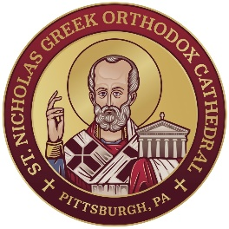
WELCOME TO ST. NICHOLAS CATHEDRAL!

VISIT www.stnickspgh.org for news and updates about our parish!
CLERGY: Rev. Fr. Eleftherios Constantine and Rev. Dn. Robert Lykos
Father’s e-mail address: fr.ec@stnickspgh.org
PROTOPSALTRIA: Amy Hogg
CHOIR DIRECTOR: Steve Andrews | ORGANIST: Brett Wells

Questions about our Parish? E-mail church@stnickspgh.org or call 412-682-3866
Our weekly Sunday worship schedule: Orthros 8:15 a.m. & Divine Liturgy 9:30 a.m.
WELCOME, VISITORS! You are honored guests here at St. Nicholas Cathedral and welcome at all our services. We invite you to receive the Holy Eucharist (Communion) if you are an Orthodox Christian who is prepared through fasting, prayer, and confession. If you are not Orthodox, or are Orthodox but have not prepared, we respectfully invite you instead to come forward at the end of the service for a blessing by the priest and a piece of blessed bread (antidoron).


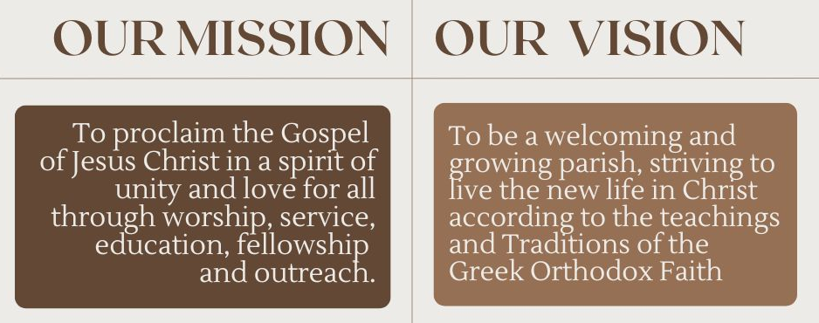
If you cannot join us in person, you may participate in our services live at www.stnickspgh.org/ by selecting the link
“Click Here for Live Streaming.”

TODAY:
- Happy New Year!
- Vasilopita cutting
- Coffee Hour hosted by GOYA in the Large Hall.

THIS WEEK AT ST. NICHOLAS:
- Monday, January 5: Royal Hours of Theophany 10:00 a.m.
Vesperal Divine Liturgy of St Basil the Great
(followed by the Great Agiasmos) 6:00 p.m.
- Tuesday, January 6: THEOPHANY Festal Orthros 8:30 a.m.
Divine Liturgy 9:30 a.m. (followed by the Great Agiasmos)
Adult Greek Classes 6:30 p.m.
- Wednesday, January 7: Synaxis of John the Holy Glorious Prophet, Baptist & Forerunner
Orthros 8:30 a.m.; Divine Liturgy 9:30 a.m.
- Friday, January 9: GOYA Holiday Party at Boyce Park
- Saturday, January 10: Greek School 10:00 a.m.

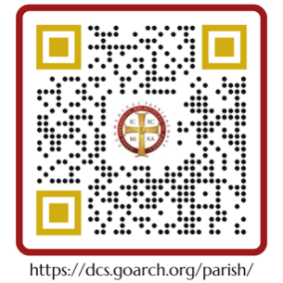
TODAY’S HYMNS AND READINGS

The Resurrection Hymn of the week in pl. 1st mode is chanted twice for the Small Entrance:
Τὸν συνάναρχον Λόγον Πατρὶ καὶ Πνεύματι, τὸν ἐκ Παρθένου τεχθέντα εἰς σωτηρίαν ἡμῶν, ἀνυμνήσωμεν πιστοὶ καὶ προσκυνήσωμεν· ὅτι ηὐδόκησε σαρκί, ἀνελθεῖν ἐν τῷ Σταυρῷ, καὶ θάνατον ὑπομεῖναι, καὶ ἐγεῖραι τοὺς τεθνεῶτας, ἐν τῇ ἐνδόξῳ ἀναστάσει αὐτοῦ.
As the Father and Spirit are unoriginate, so the Word, who was born from the Virgin for us. Let us praise Him, O believers, and let us worship Him. For our salvation He was pleased to be crucified in the flesh, and to undergo death, and to resurrect the dead, by His glorious resurrection.

At the Small Entrance, the usual Entrance Hymn is chanted.

Following the Small Entrance, the Resurrection Hymn of the week in plagal first mode is repeated (see above).

Then we chant the Apolytikion hymn for the day (the Forefeast of Theophany), in fourth mode:
Ἑτοιμάζου Ζαβουλών, καὶ εὐτρεπίζου Νεφθαλείμ. Ἰορδάνη ποταμέ, στῆθι ὑπόδεξαι σκιρτῶν, τοῦ βαπτισθῆναι ἐρχόμενον τὸν Δεσπότην. Ἀγάλλου ὁ Ἀδὰμ σὺν τῇ Προμήτορι· μὴ κρύπτετε ἑαυτούς, ὡς ἐν Παραδείσῳ τὸ πρίν· καὶ γὰρ γυμνοὺς ἰδὼν ὑμᾶς ἐπέφανεν, ἵνα ἐνδύσῃ τὴν πρώτην στολήν. Χριστὸς ἐφάνη, τὴν πᾶσαν κτίσιν, θέλων ἀνακαινίσαι.
O Zabulon, prepare, and be ready, Nephthalim. Jordan River, hold your course, and exultantly receive the Master who is coming to be baptized. Adam leap for joy with Eve the Foremother. No longer hide yourselves, as once in Paradise; for having seen you naked He has appeared to clothe you in your former vesture. The Christ has appeared, wishing to renew the entire creation.

We then chant the Apolytikion hymn for our patron, St. Nicholas, in fourth mode:
Κανόνα πίστεως καὶ εἰκόνα πραότητος, ἐγκρατείας διδάσκαλον, ἀνέδειξέ σε τῇ ποίμνῃ σου, ἡ τῶν πραγμάτων ἀλήθεια· διὰ τοῦτο ἐκτήσω τῇ ταπεινώσει τὰ ὑψηλά, τῇ πτωχείᾳ τὰ πλούσια, Πάτερ ἱεράρχα Νικόλαε· πρέσβευε Χριστῷ τῷ Θεῷ, σωθῆναι τὰς ψυχὰς ἡμῶν.
The truth of things have revealed you to your flock as a rule of faith, an icon of meekness, and a teacher of temperance; for this cause you have achieved the heights by humility, riches by poverty. O Father and Hierarch Nicholas, intercede with Christ God that our souls be saved.

Finally, we chant the Festal Kontakion (for the Forefeast of Theophany), in fourth mode:
Ἐν τοῖς ῥείθροις σήμερον τοῦ Ἰορδάνου, γεγονὼς ὁ Κύριος, τῷ Ἰωάννῃ ἐκβοᾷ· Μὴ δειλιάσῃς βαπτίσαι με· σῶσαι γὰρ ἥκω, Ἀδὰμ τὸν πρωτόπλαστον.
To the flowing streams today of River Jordan comes the Lord and cries aloud to John the Baptist, and He says, “Be not afraid to baptize me now; for I have come to save Adam, the first-formed man.”

Today’s Epistle Reading (Sunday Before Theophany):
The reading is from St. Paul’s Second Letter to Timothy (4:5-8)
Τέκνον Τιμόθεε, νῆφε ἐν πᾶσι, κακοπάθησον, ἔργον ποίησον εὐαγγελιστοῦ, τὴν διακονίαν σου πληροφόρησον. Ἐγὼ γὰρ ἤδη σπένδομαι, καὶ ὁ καιρὸς τῆς ἐμῆς ἀναλύσεως ἐφέστηκε. Τὸν ἀγῶνα τὸν καλὸν ἠγώνισμαι, τὸν δρόμον τετέλεκα, τὴν πίστιν τετήρηκα· λοιπὸν ἀπόκειταί μοι ὁ τῆς δικαιοσύνης στέφανος, ὃν ἀποδώσει μοι ὁ Κύριος ἐν ἐκείνῃ τῇ ἡμέρᾳ, ὁ δίκαιος κριτής, οὐ μόνον δὲ ἐμοί, ἀλλὰ καὶ πᾶσι τοῖς ἠγαπηκόσι τὴν ἐπιφάνειαν αὐτοῦ.

Timothy, my son, always be steady, endure suffering, do the work of an evangelist, fulfil your ministry. For I am already on the point of being sacrificed; the time of my departure has come. I have fought the good fight, I have finished the race, I have kept the faith. Henceforth there is laid up for me the crown of righteousness, which the Lord, the righteous judge, will award to me on that Day, and not only to me but also to all who have loved his appearing. [RSV]

Today’s Gospel Reading (Sunday Before Theophany):
The reading is from the Holy Gospel according to Mark (1:1-8)
Ἀρχὴ τοῦ εὐαγγελίου Ἰησοῦ Χριστοῦ, υἱοῦ τοῦ Θεοῦ. Ὡς γέγραπται ἐν τοῖς προφήταις, ἰδοὺ ἐγὼ ἀποστέλλω τὸν ἄγγελόν μου πρὸ προσώπου σου, ὃς κατασκευάσει τὴν ὁδόν σου ἔμπροσθέν σου· φωνὴ βοῶντος ἐν τῇ ἐρήμῳ, ἑτοιμάσατε τὴν ὁδὸν Κυρίου, εὐθείας ποιεῖτε τὰς τρίβους αὐτοῦ, ἐγένετο Ἰωάννης βαπτίζων ἐν τῇ ἐρήμῳ καὶ κηρύσσων βάπτισμα μετανοίας εἰς ἄφεσιν ἁμαρτιῶν. Καὶ ἐξεπορεύετο πρὸς αὐτὸν πᾶσα ἡ Ἰουδαία χώρα καὶ οἱ Ἱεροσολυμῖται, καὶ ἐβαπτίζοντο πάντες ἐν τῷ Ἰορδάνῃ ποταμῷ ὑπʼ αὐτοῦ ἐξομολογούμενοι τὰς ἁμαρτίας αὐτῶν. Ἦν δὲ ὁ Ἰωάννης ἐνδεδυμένος τρίχας καμήλου καὶ ζώνην δερματίνην περὶ τὴν ὀσφὺν αὐτοῦ, καὶ ἐσθίων ἀκρίδας καὶ μέλι ἄγριον. Καὶ ἐκήρυσσε λέγων· ἔρχεται ὁ ἰσχυρότερός μου ὀπίσω μου, οὗ οὐκ εἰμὶ ἱκανὸς κύψας λῦσαι τὸν ἱμάντα τῶν ὑποδημάτων αὐτοῦ· ἐγὼ μὲν ἐβάπτισα ὑμᾶς ἐν ὕδατι, αὐτὸς δὲ βαπτίσει ὑμᾶς ἐν Πνεύματι Ἁγίῳ.

The beginning of the Gospel of Jesus Christ, the Son of God. As it is written in Isaiah the prophet, ‘Behold, I send my messenger before your face, who shall prepare your way; the voice of one crying in the wilderness: prepare the way of the Lord, make his paths straight.’ John the baptizer appeared in the wilderness, preaching a baptism of repentance for the forgiveness of sins. And there went out to him all the country of Judea, and all the people of Jerusalem; and they were baptized by him in the river Jordan, confessing their sins. Now John was clothed with camel’s hair, and had a leather girdle around his waist, and ate locusts and wild honey. And he preached, saying, “After me comes he who is mightier than I, the thong of whose sandals I am not worthy to stoop down and untie. I have baptized you with water; but he will baptize you with the Holy Spirit.” [RSV]

SAINTS ALIVE!

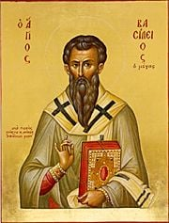

January 4th
- Synaxis of the 70 Holy Apostles
- Our Righteous Father Theoctistos
- Nikephoros the Leper

January 5th
- The Holy Martyrs Theopemptos and Theonas

January 6th
- The Theophany of Our Lord and Saviour Jesus Christ

January 7th
- Synaxis of John the Holy Glorious Prophet, Baptist, & Forerunner

January 8th
- George of Hozeva
- Domnica the Righteous of Constantinople

January 9th
- Polyeuctos the Martyr of Melitene in Armenia
- Eustratios the Wonderworker

January 10th
- Gregory of Nyssa
- Dometian, Bishop of Melitene

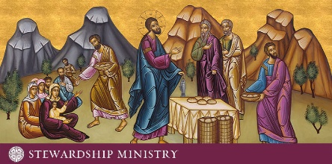

"Your Own of Your Own, we offer to You…"

We offer back to God that which He has given us.

Visit our website to fill out a Stewardship Card or to donate at https://stnickspgh.org.

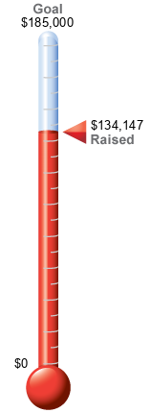
2025 | STEWARDSHIP
Total Stewards | 301 (GOAL 300)
Total Pledged | $ 168,223.00  (GOAL ($255,000.00)
Avg. Pledge | $ 966.80

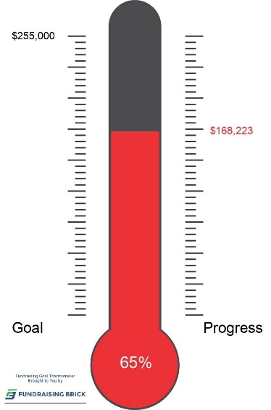
Stewardship 2025: Thank you to our new and returning Saint Nicholas Stewards!
For those who have not filled out a card, please do so as our church depends on stewardship for ongoing ministries as well as maintaining our beautiful Cathedral.

Cards are available in the Narthex and online at http://www.stnickspgh.org.

From the Church School Desk:

Many hats, mittens/gloves, scarves, socks, and coats will be delivered to Neighborhood Resilience Project for their Project Bundle-up. Thanks to all who contributed to this worthwhile cause.
The Metropolis of Pittsburgh’s Oratorical Education Sunday will be Sunday, January 25, 2026. Previous St. Nicholas Cathedral Oratorical Festival participants will pass a special tray to benefit the Metropolis of Pittsburgh’s Peter Clyde Papadakos Memorial Oratorical Scholarship Fund. Proceeds from the tray will be used to award cash scholarships to the top two (2) finalists in each Division (Junior and Senior) at the Metropolis Festival Saturday, May 2, 2026, at the New Metropolis Center (Washington, PA).

I appreciate the support from all of you and thanks for sharing your children with us every Sunday!

Yours in Christ
Miss Michelle



PHILOPTOCHOS NEWS
Philoptochos is trying to put together a list of individuals who are willing and able to help the area college students (Pitt, CMU, Carlow, Chatham, Duquesne, RMU, CCAC, Penn State (Pittsburgh), Point Park, and LaRoche) during their stay here in Pittsburgh. A list of drivers, doctors, dentists, pharmacists, etc. is being compiled so they will have someone to call. Your assistance will be greatly appreciated. The goal is to have this list complete by the end of the year for distribution in January (next semester’). For more information, contact Michelle Kotsagrelos at 412-680-1416.

SIXTY CLUB NEWS

SAVE the DAY: January 25, 2026
EVERYONE IS INVITED
USA Birthday Party--250 years. Look for details.
Anyone willing to join the planning committee for this event, please contact Alice Gary ( 412-249-8612 ) this week.
Please remit $15.00 dues to Argie Stuart for 2025-2026.

Homewood Cemetery
St. Nicholas Greek Orthodox Cathedral Greek Section

There are currently 23 graves available for purchase.

Cost per grave:
$2,800.00 per grave for a member of St. Nicholas.
$3,300.00 per grave for non-member.

Contact the Church Office at 412-682-3866 for further information.

SIXTY CLUB NEWS

SAVE the DATE: January 25, 2026
EVERYONE IS INVITED
USA Birthday Party--250 years. Look for details.
Anyone willing to join the planning committee for this event, please contact Fran Hanna
(412-731-0790) this week.
Please remit $15.00 dues to Argie Stuart for 2025-2026.

Food Festival Preparations 2026
We’re gearing up again this week with our food festival preparations. Join us whenever you can to help prepare our pans of Spanakopita. All help is appreciated. We will be assembling the pans Wednesday, Thursday and Friday, January 7, 8 and 9 from 9:00 to 4:00pm.
January At A Glance
- Spanakopita, January 7, 8 and 9
- Souzoukakia, Friday and Saturday, January 16 and 17
- Pastitsio, Tuesday, Wednesday, January 27 and 28

GOYA NEWS

ST. NICHOLAS SWEATSHIRTS

A new order for sweatshirts (White with Blue lettering) will be placed for our Parishioners, GOYANS, Coaches, and Parents.
Crewnecks $20
Hoodies $30
Additional cost $5 for name on back
2X and 3X additional $3
Checks payable to St. Nicholas GOYA
Deadline for ordering is December 30th.
For more information text/call
Linda 412-523-7938.

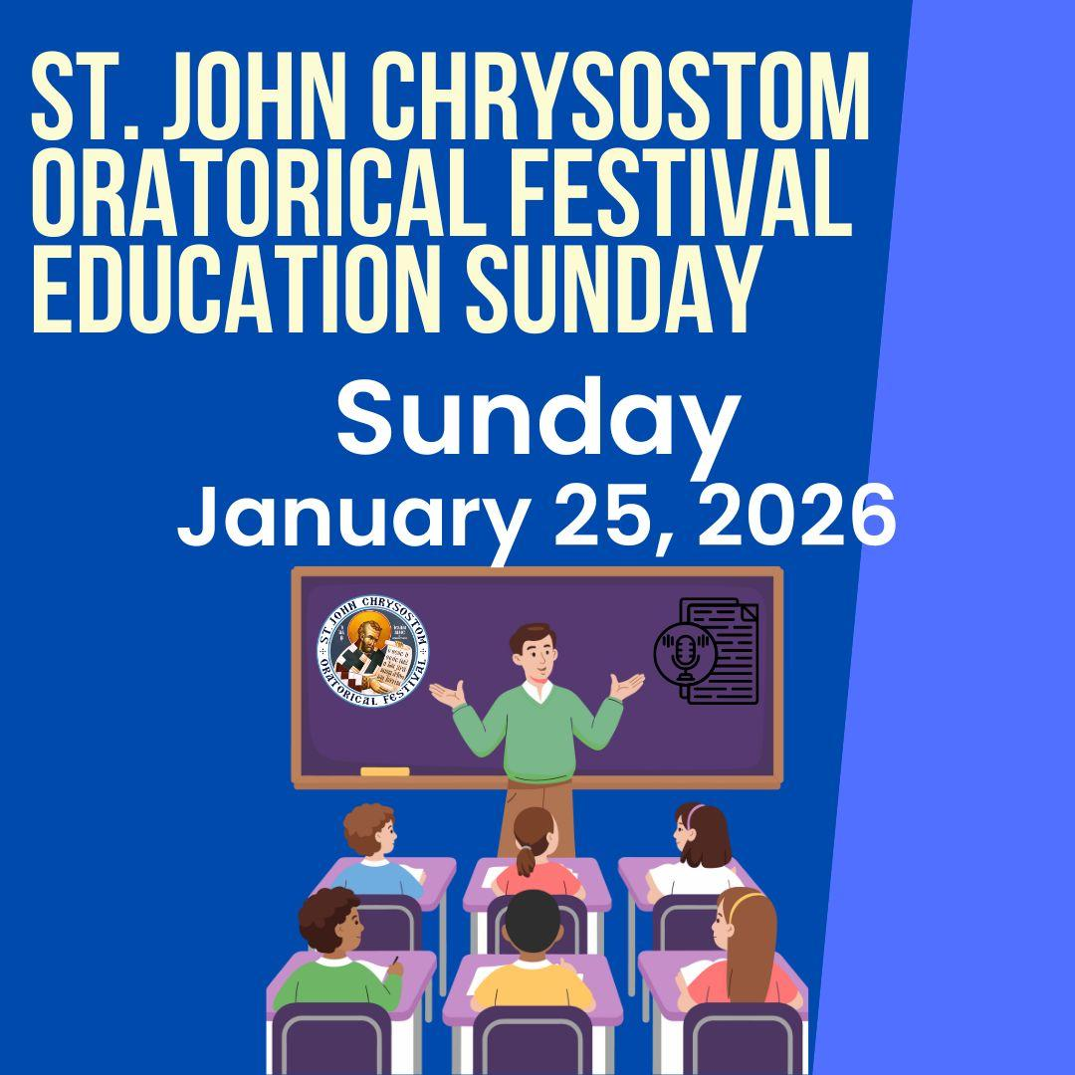

JANUARY 2026
Sunday | Monday | Tuesday | Wednesday | Thursday | Friday | Saturday
4  Sunday  before  Theophany  Orthros  8:15 a.m.  Divine Liturgy  9:30 a.m.  Cutting of Vasilopita | 5  Royal Hours  of  Theophany  10:00 a.m.  Vesperal  Divine Liturgy  Of  St. Basil the Great  (followed by the Great Agiasmos)  6:00 p.m. | 6  THEOPHANY  Festal Orthros  8:30 a.m.  Divine Liturgy  9:30 a.m.  (followed by the Great Agiasmos)  Adult Greek Classes  6:30 p.m. | 7  Synaxis  of  John  the Holy Glorious Prophet, Baptist, & Forerunner  Orthros  8:30 a.m.  Divine Liturgy  9:30 a.m.  YAL Volleyball  7:00 p.m. | 8 | 9  GOYA  Holiday Party  at  Boyce Park | 10  Greek School  10:00 a.m
11  Sunday  after  Theophany  Orthros  8:15 a.m.  Divine Liturgy  9:30 a.m. | 12  Bible Study  5:30 p.m.  YAL Basketball  7:00 p.m. | 13  Adult Greek Classes  6:30 p.m. | 14 | 15  Pitt/CMU OCF  7:30 p.m. | 16  GOYA BBall Tourney in Columbus, OH | 17  Greek School  10:00 a.m.
18  12th Sunday  of  Luke  Orthros  8:15 a.m.  Divine Liturgy  9:30 a.m. | 19  Bible Study  5:30 p.m.  Parish Council  Meeting  6:30 p.m.  YAL Basketball  7:00 p.m. | 20  Adult Greek Classes  6:30 p.m. | 21  St. Maximos  the Confessor  Orthros  8:30 a.m.  Divine Liturgy  9:30 a.m.  YAL Volleyball  7:00 p.m. | 22  Pitt/CMU OCF  7:30 p.m. | 23 | 24  Greek School  10:00 a.m
25  15th Sunday  of  Luke  Orthros  8:15 a.m.  Divine Liturgy  9:30 a.m.  Philoptochos  Membership Drive  Oratorical Education Sunday  Happy 250 USA Celebration | 26  Bible Study  5:30 p.m.  YAL Basketball  7:00 p.m. | 27  Adult Greek Classes  6:30 p.m. | 28 | 29  Pitt/CMU OCF  7:30 p.m. | 30  Synaxis  of  The  Three Hierarchs  Orthros  8:30 a.m.  Divine Liturgy  9:30 a.m.  GOYA BBall Tourney in Cleveland, OH | 31  Greek School  10:00 a.m

